My.monasmy.monas

RESUME

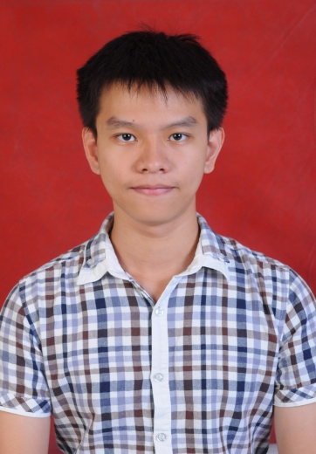

Name : **Kevin AprilioGani**

Current Address : **Sunway Lagoon View B-18-06, JalanUniversiti, Bandar Sunway, 46150 Petaling Jaya**

Permanent Address : **Jalan Raya Kutisari Indah no. 45, Surabaya, JawaTimur, Indonesia**

Mobile No : **+60108985783/+628193828617**

Email : [**kevin.aprilio.28@hotmail.com**](mailto:kevin.aprilio.28@hotmail.com)

Expected salary : **RM 2100**

PERSONAL DETAILS

**PERSONAL INTEREST**

* Hiking and jungle trekking
* Reading
* Swimming and playing badminton
* Travelling
* Cooking
* Open to new and various experience

Age : **22 years old**

Nationality : **Indonesian**

Marital status : **Single**

Date of Birth : **28 April 1992**

Gender : **Male**

Passport : **U717085**

**HIGHEST EDUCATION**

Level : Bachelor of Science (Food Science and Technology)

Field of study : Science

Major : Food Science and Technology

University/Institute : Monash University, Malaysia

Current GPA : 2.96

Grade : 72.6/100

Course date : 2011 - 2014

EDUCATIONAL BACKGROUND

Company Name : Haco Asia Pacific Sdn Bhd., Malaysia

Type of Job : Industrial Training/Internship Program

Department : QA/QC

Working Period : 26th November 2013 – 14th February 2014

Job Description : 1. Preparing and participating in sensory test of the product which is coffee.

2. Performing shelf life tests (moisture, colour, and pH analysis).

3. Analysing errors and source of errors in the products.

WORK EXPERIENCE

SKILLS

**LANGUAGES**

English : Good Fluency

Bahasa Indonesia : Native Fluency

Bahasa Melayu : Good Fluency

Chinese : Moderate Fluency

**LABORATORY SKILLS**

1. Microbiology test (Microbial culture, staining technique, microbiology analysis, etc.).
2. Work with various types of chemicals (including those with flammable and corrosive properties).
3. Shelf life tests (moisture, colour,texture and pH analysis).
4. Sensory tests.
5. Laboratory reports.
6. Time management in doing the laboratory practical as well as laboratory reports.

**TEAMWORK SKILLS**

I am used to work in the groups whether in doing assignments given by university or in preparing community service events for Monash University Leo Club, Malaysia.

**LEADERSHIP SKILLS**

* Group leader and one of the Board of Directors in Monash University Leo Club, Malaysia.
* Guiding the team members in preparing events to fulfil the objectives of saving the environment.
* Solving any problems which can become obstacles in carrying the events.

**COMMUNICATION, TIME MANAGEMENT, AND ORGANISING SKILLS**

AWARDS

* Contribution in ‘Buddy Scheme’ program by Monash University, Malaysia.
* Contribution as Facilitator for ‘Monash Amazing Race’ by Monash University Student Association.
* Contribution as Facilitator for ‘Monash Run’ by Monash University, Malaysia.
* Contribution as one of the Board of Directors as Tropicana Group Leader in Monash University Leo Club, Malaysia.
* Outstanding Leo Club Director 2013-2014.

VOLUNTARY WORKS

* Helping in cleaning an orphanage home for one semester.
* Helping to clean Zoo Negara and feed the animals.
* Helping to sell food for donation drive.
* Helping to promote the usage of recycling bags during Go Green Week.
* Becomes guide for new students in ‘Buddy Scheme’program.
* Becomes facilitator for ‘Monash Amazing Race’ and ‘Monash Run’.
* Becomes organizer for BaganLalang Beach Cleaning event at Sepang, Malaysia.
* Becomes organizer in Tree Planting Event at Raja Musa Forest Reserve Malaysia as collaboration event with Global Environment Centre (Malaysian NGO).
* Becomes organizer for one of the bazaar events held within Monash University, Malaysia campus.
* Becomes organizer for a photography competition held within Monash University, Malaysia campus.